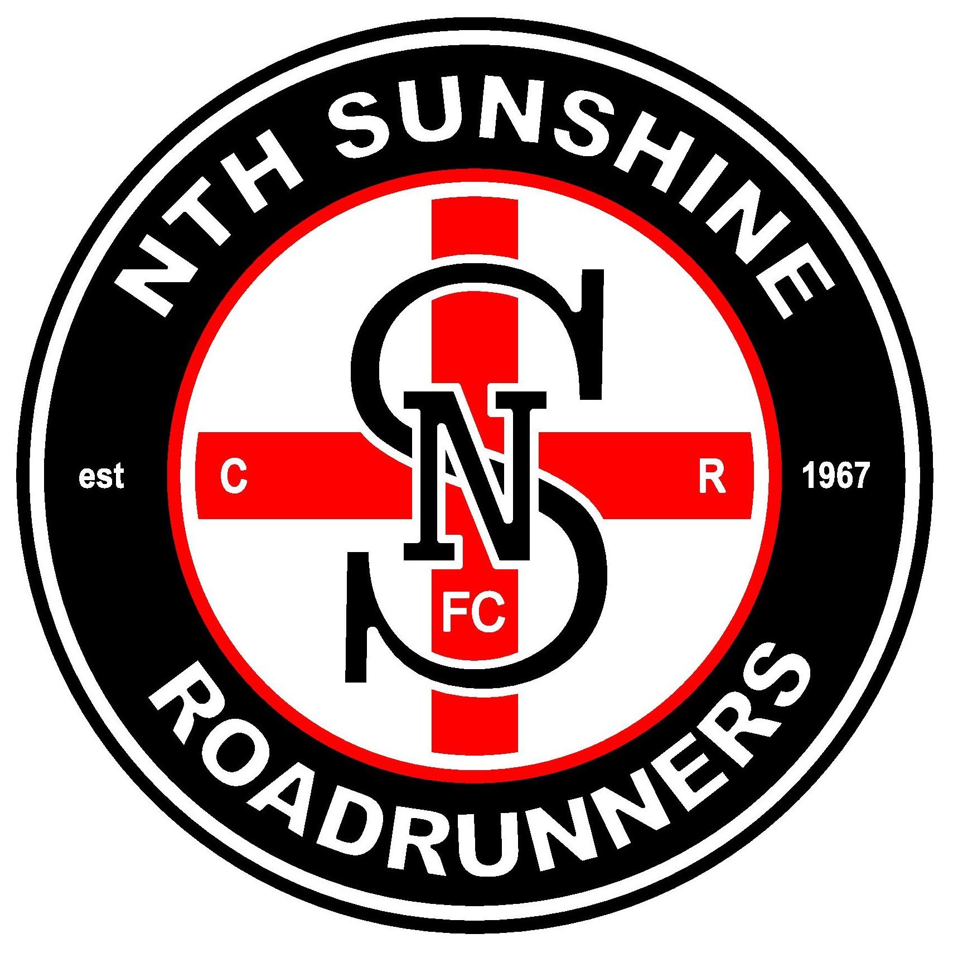

NORTH SUNSHINE FC SEEKS COACHES

North Sunshine Football Club is currently seeking applications or expressions of interest for a number of coaching positions in 2018.

- Reserves Coach
- U/19’s Football Coach
- Senior Women’s Coach
- Assistant Football Coaches
(playing or non-playing roles)

We are a young and developing list playing in the WRFL, who are keen on building on a successful 2017 season. We are a proud club, with over 50 years of history, and in 2018 we will embark on a new journey with our first Senior Women’s football team.

This is a positive place to build a coaching resume, with a strong Senior Coach who is keen to mentor new coaches. All applicants should still have a strong knowledge of the modern game and have a keen interest in player development.
Applications must be received by close of business Friday 13th of October.

Contact: Brett Kennerley
Phone: 0466133505
Email: brett.k.seniorcoach.nsfc@gmail.com

